Self-Assessment Protocol for District Race to the Top Plan

- Review the Race to the Top Road Map.
  - Read across the category, Practice: Continuous Improvement, to become re-familiarized with the goals for this category.
  - Re-read each box and cross off any goals in that box that you have accomplished as a district. If you have completed all of the goals in a box, cross off the box with an “X”.
  - Circle any goals your district has not accomplished.
  - Repeat steps 1a and 1b for the categories, Data Driven: Common Formative Assessment and Standards: Guaranteed and Viable until all boxes are reviewed.

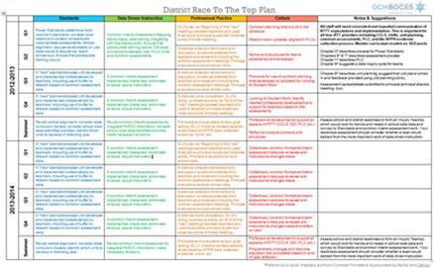
- Review the 2-year District Race to the Top Plan.
  - Read down the category, Standards, to become re-familiarized with the Action Steps for each quarter.
  - Re-read each Action Step and cross it off with an “X” if you have accomplished it as a district. Please note, six standards-based units should have been collaboratively developed at this time.
  - Circle any Action Steps your district has not accomplished.
  - Repeat steps 2a and 2b for the categories, Data-Driven Instruction, Professional Practice, and Culture.

- Complete the District Race to the Top Self-Assessment and Action Planning Tool.
  - Using the results from Steps 1 and 2, rate your district’s progress towards the RTTT goals.
  - Identify Action Steps and supports needed for each category.

